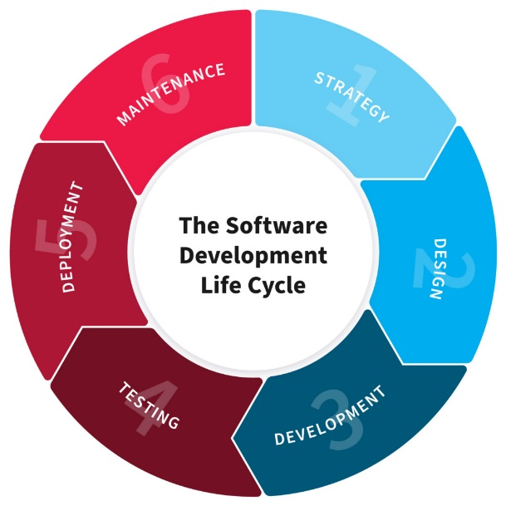

**BIT YEAR 2**

|  |  |
| --- | --- |
| ss  **airline ticket management system** | names: uwiragiye moisie  reg no: 221018083  class no: group3  project name: airline ticket managemet system |

***AIRELINE TICKET MANAGEMENT SYSTEM***

* ***PLANNING***

Airline ticket management system is system that allow an airline to sell inventory(seats).It contains all information of on schedules a and fares this project or system contains a database of passenger records(names, Tel, date and) help the whole company to register all customer need the ticket depends on the customer wants to go .This Airline ticket management system also contains the all details about: passengers, Flight, booking and cancelation. According to the problems faced before we had an idea about to create or design the system that help the company to simplify the work in full security and work the side on company that differ to online system.

***Goals and objectives this system:*** there is goals and objectives we have in this process of building this system such as:

1. Maintaining safe records.
2. To make the business more efficient.
3. Provide accurate information about the addition and modification or records.
4. To record the details various activities of user.
5. Provide an alternative system that will be used and interfaced by the authorized airline employee to manage the system and utility.

***Problems this system comes to solve:*** there is many problems this system comes to solve such as time consuming. actually time consuming is one of biggest problems we had in existing system and this project comes to manage the time with clear and easiest way because this system contains the digital technology that leads to make somethings quickly. another problem our system comes to solve is insecurity of data. This is the problems we had in existing system of lack of security and then this system comes to keep our data safely. Other problems we faced is human error would be frequent. Because of using manually system might leads to make unplanned error and could caused the problems and then this project comes to solve that problem because of the way it designed is telling you if you make mistake or make wrong in when you recording the data.

* ***Design***

Airline ticket management system design is the process of defining the architecture ,components, modules, interface and data for a system to satisfy specified requirements.

All operations of an airline controlled by their airline ticket management system .this system involved scheduling of flight, passenger, booking and cancelation. Daily flights updates can also be retrieved by using the system. first of all open the system and then make login and brings to homepage and homepage interface include four menus such as passenger, flight, booking and cancelation and click where you want to click on depends.

***System requirements:*** users of the system are able to make login(have username and password)and able to enter the record of passengers in database. users of the system can check the flight schedules, their departure time, available seats and other flight details. user may cancel the ticket when passenger canceling her/his flight. user can update customer’s records. users may records passenger information.

* ***Development***

This airline ticket management system build all system include login ,passengers, flight, booking and cancelation. airline ticket management system has graphical user interface(GUI) that will help us to retrieving, storing and updating the all data through various user friendly menu-modules.

In our project we use software in build this system or graphical user interface is called ”NetBeans”. opening of NetBeans to create new java project and get on well the interface using java strings. This NetBeans helped us to design airline ticket management system through to coding that gave us this entire interface system in order to have front-end side and java program for back-end side.

Other software we used are WAMP, MySQL connector those helped us to connect our system with it’s database that our name of database we called ”My database ” . My database storing all information of the passengers with more security. We have system that are designed by NetBeans software connected with database (My database) that is called “Airline ticket management system” .

* ***Testing***

Software testing is the process of executing a program with the intention of finding errors in the code. According to this our project, we made testing in our codes before implementing it.

* Testing entire system either interface or database if works correctly
* It is necessary to test how a system will scale
* Testing plan is done to verify that all the functionality that are integrated ,works correctly.
* Verify that login have strong security
* Verify that after filling the passengers details went to the our database
* Verify that every passenger have one seat without duplication
* Verify that may update the passenger information
* Verify that cancelation the ticket to the passengers wont to go
* Verify that existing passengers has been updated
* Verify that new passengers added in our system
* Verify that passengers get the seat in the flight
* Verify that enable to user to access the system may open the system and make login and see all modules from one modules to another depends on what she/he want to do for example, go to he passengers and fill it after give the passengers seat in the flight and booking time in booking.
* Testing the system made what we want to make in simple way without complicate the work and executing all errors in our system

* ***Deployment***

In this section system will be installed after implement and This means the action of bringing resources into effective action in other words, it is the mechanism through which applications, modules, updates and patches are delivered from developers to users.

First of all we open our system in NetBeans and we get login table before to get homepage and make well login and start to use system as it’s have to do .after this section company users may able to use this system through to get all feature of it and it’s description and also verify all what the company want in order to use it in other word test the whole project. here we have some different things in deployment:

* Our system have high capacity and scalability to the user
* We used an automated software development process.
* Consume less memory of given drive or computer
* In it’s performance doesn’t need connection of internet
* All system have ability to do the work because it is well tested with errors and performance in all modules
* Users are able to do the work through recording all information of all passengers
* We made a Backup plan